IAM

It is region specific not global specific

To configure CLI we required IAM

IAM is global specific

After connecting the root account with CLI, the register secrete key we can find in our PC in .aws folder after downloading

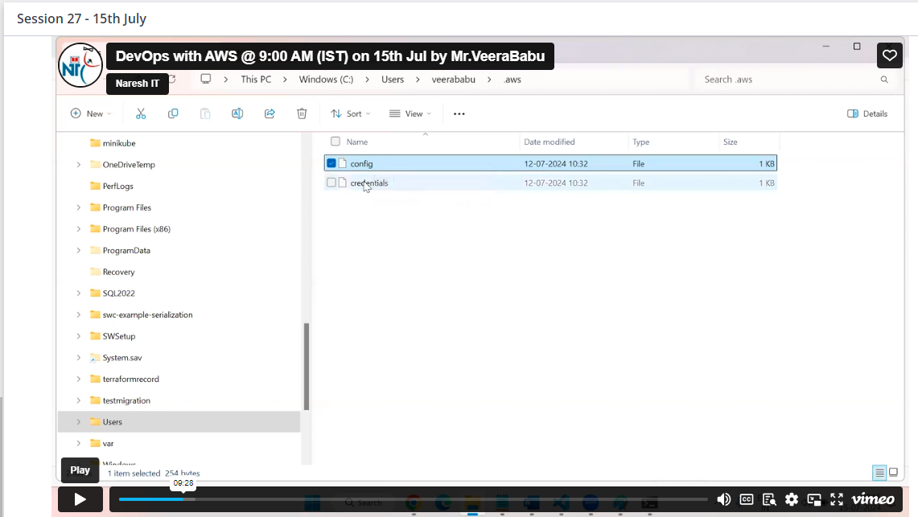

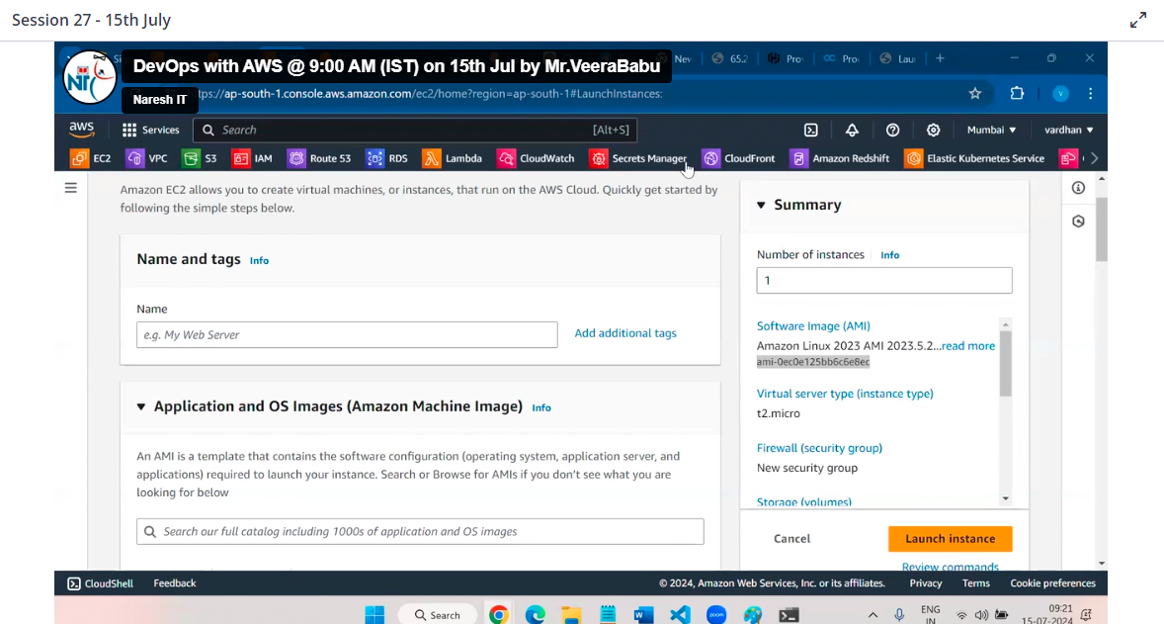

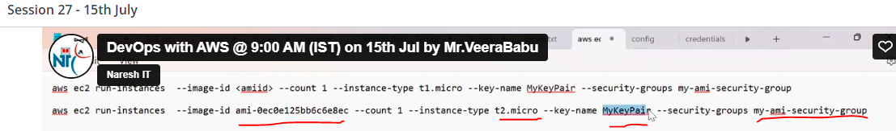

To stop instance requires instance ID

Copy ID

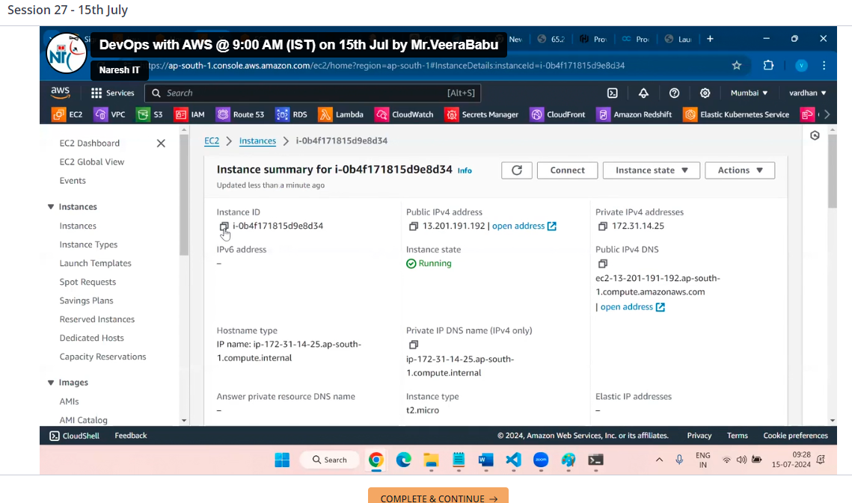

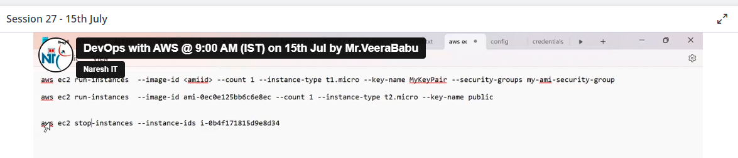

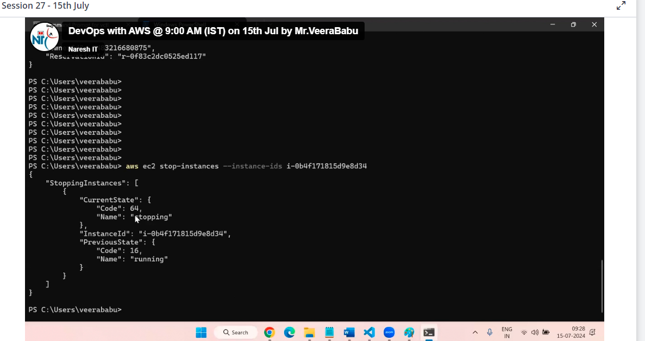

Now we can see in down img instance stopped

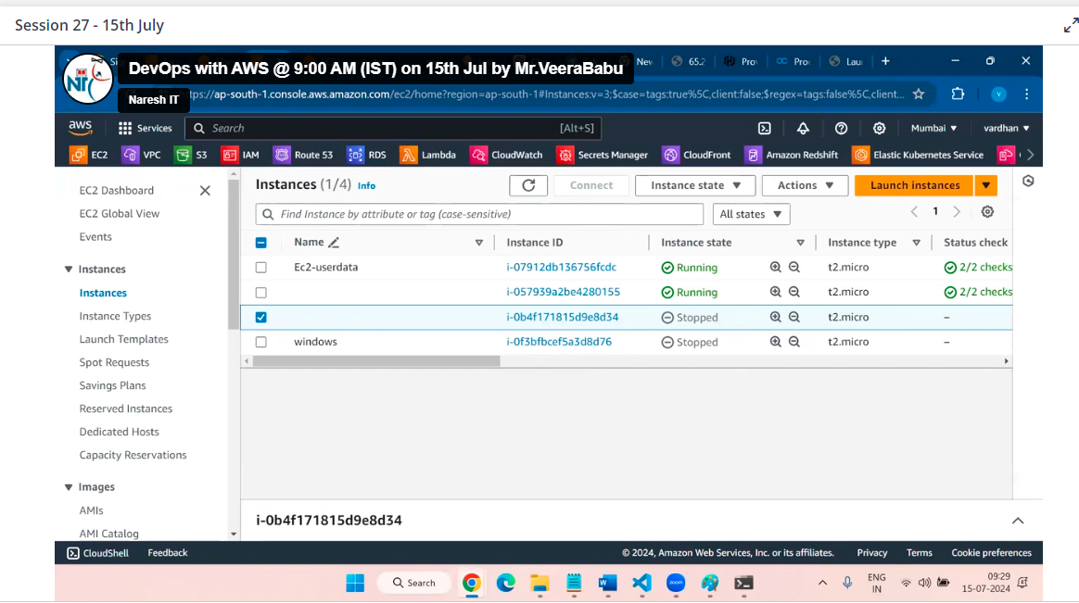

We can terminate by using

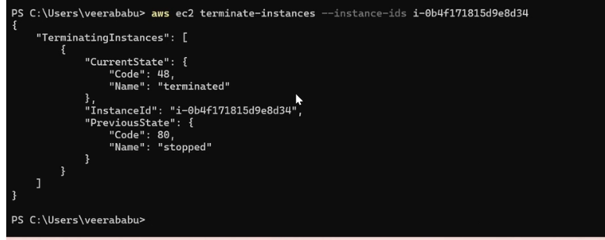

If you give other region then default region, we can see

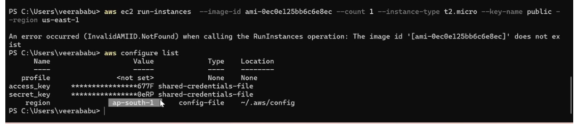

It will show error because we already give default region as ap-south-1a as default during configuration

If we need to login other account, we need to create other file

Like any name example :dev,today

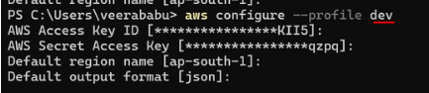

User through CLI approach

Create user with poilcies

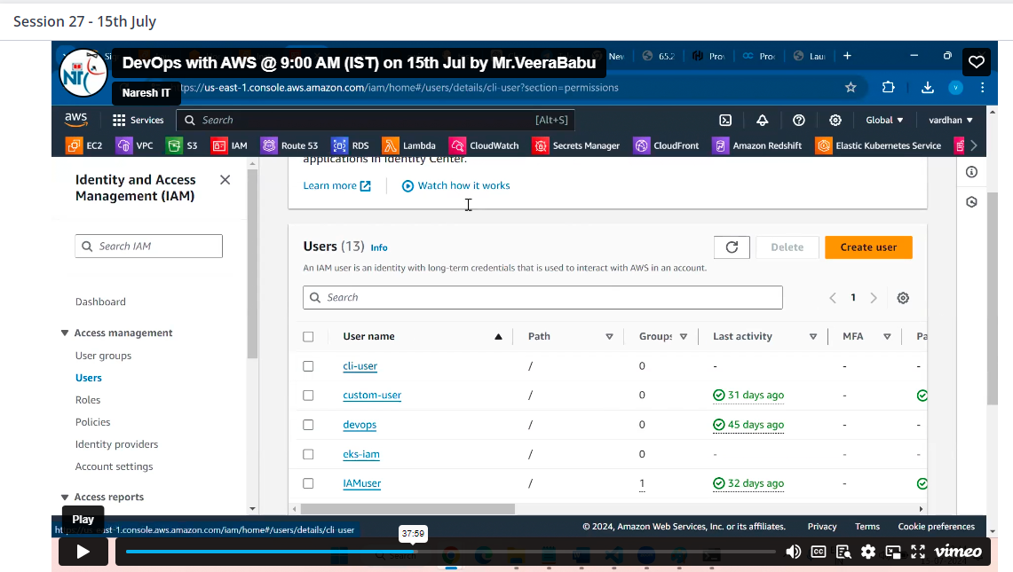

Click on user example: cli-user

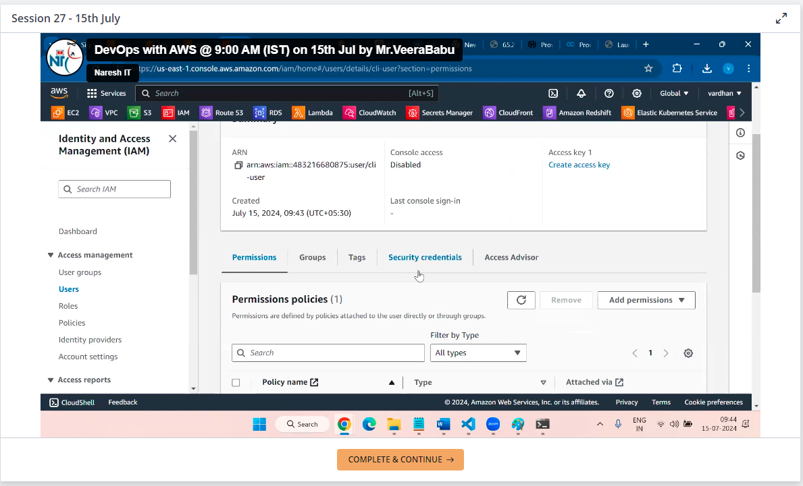

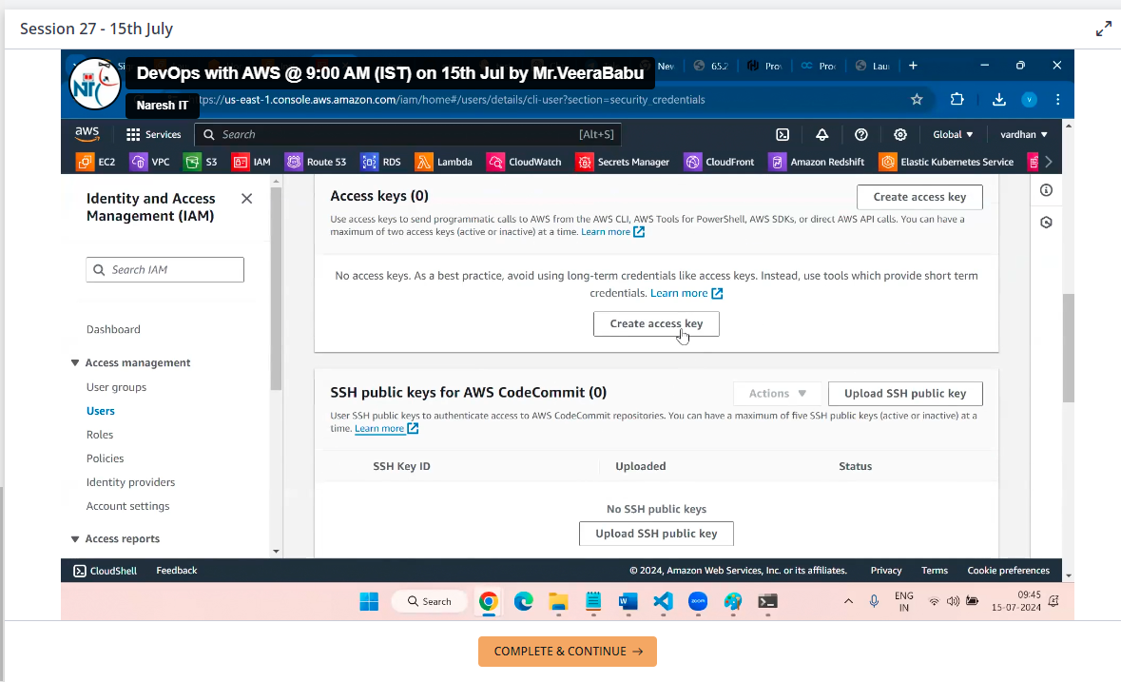

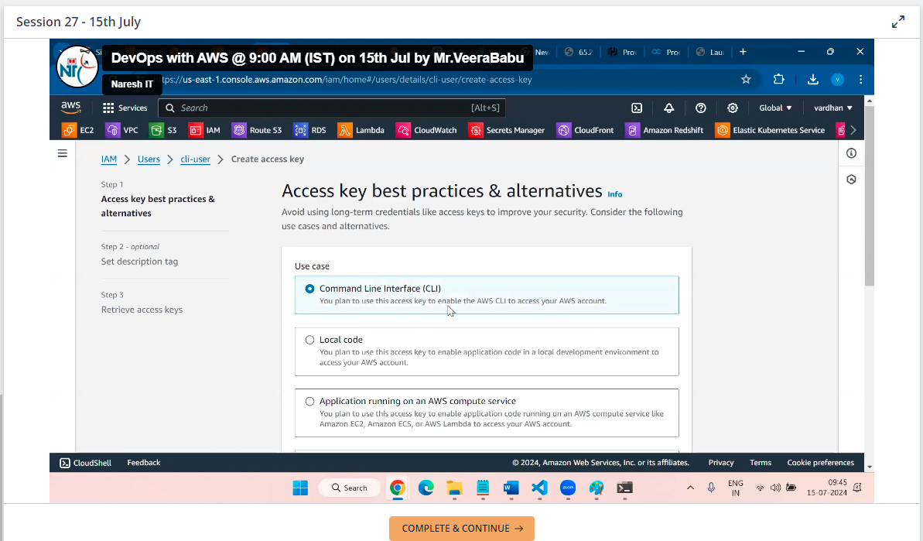

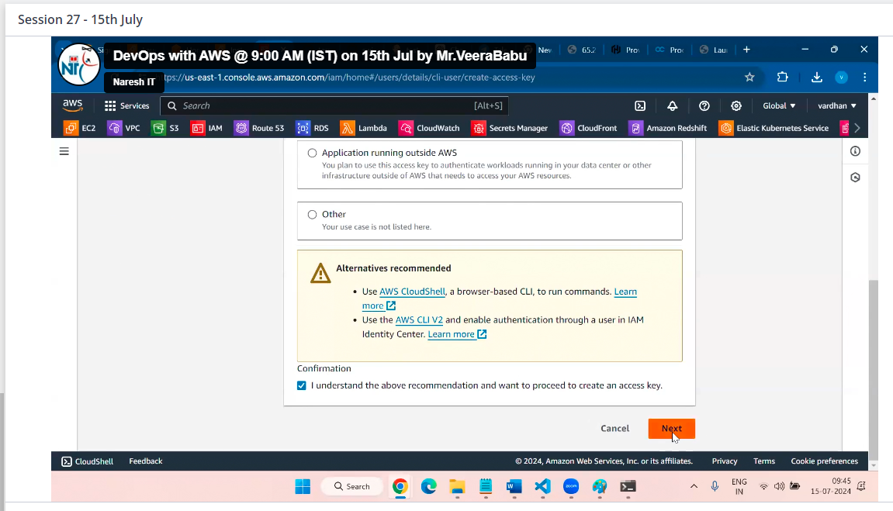  
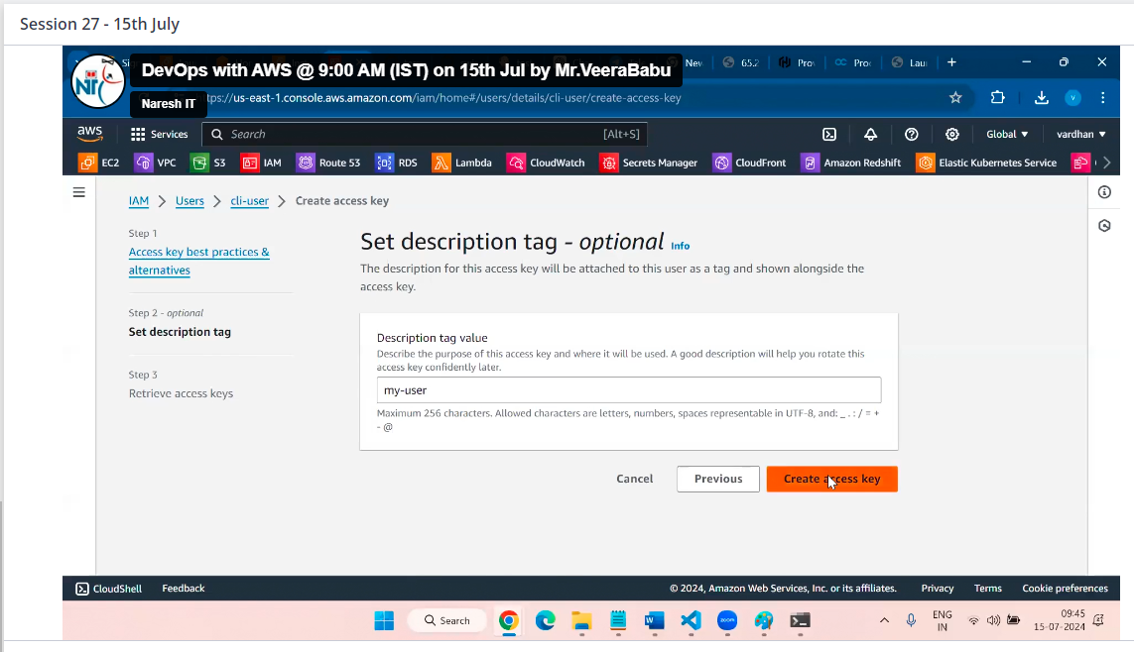

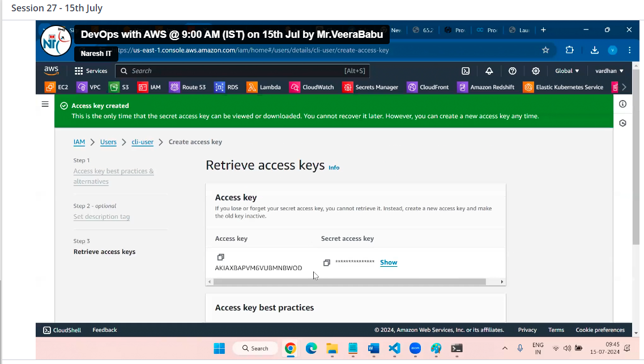

Here I am using aws configure --profile cli-user

Why because in my end I have root user login with aws configure to avoid over ride root account we are using aws configure --profile (cli-user) any name

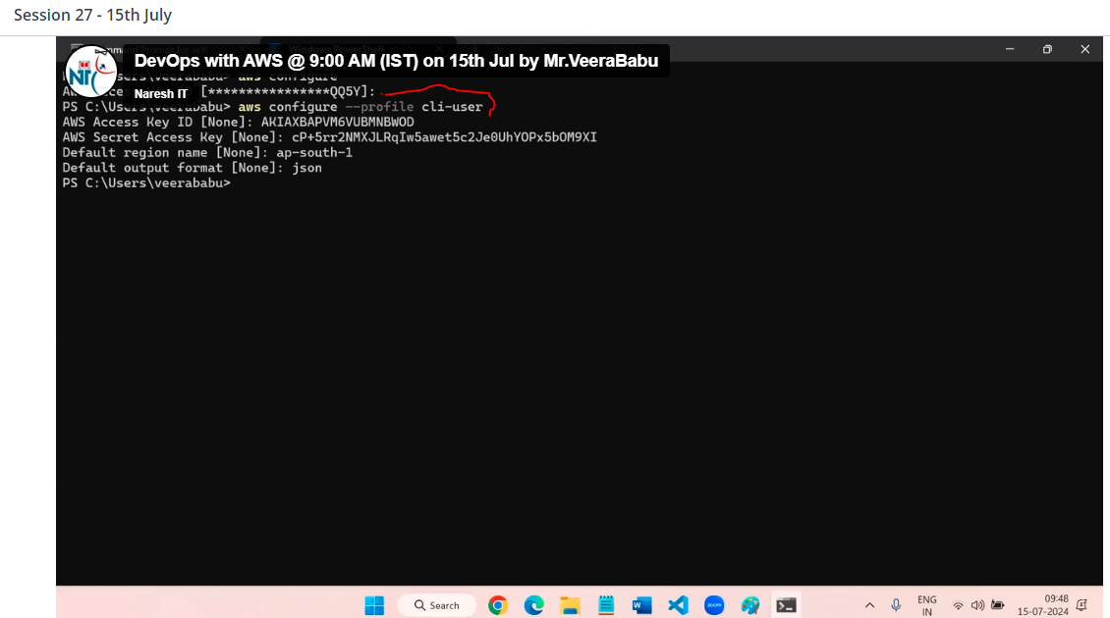

Here we have given S3 permissions

Now run command to create ec2 instance

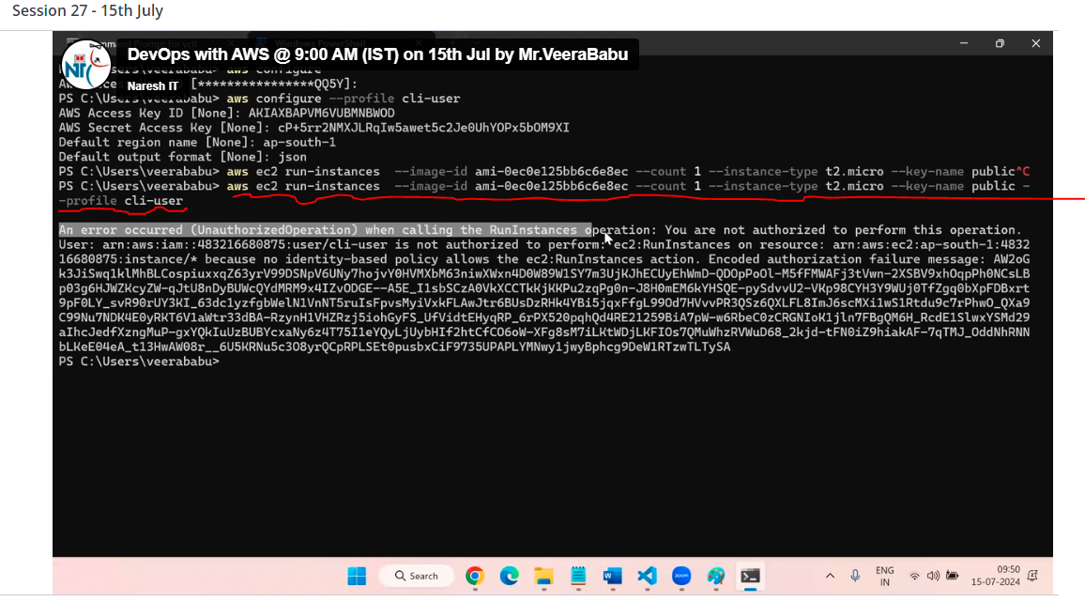

Error because having no access for ec2

Now give permission then run command then

Instance created

If run command without using --profile cli user then that instance created in default user that is in root user

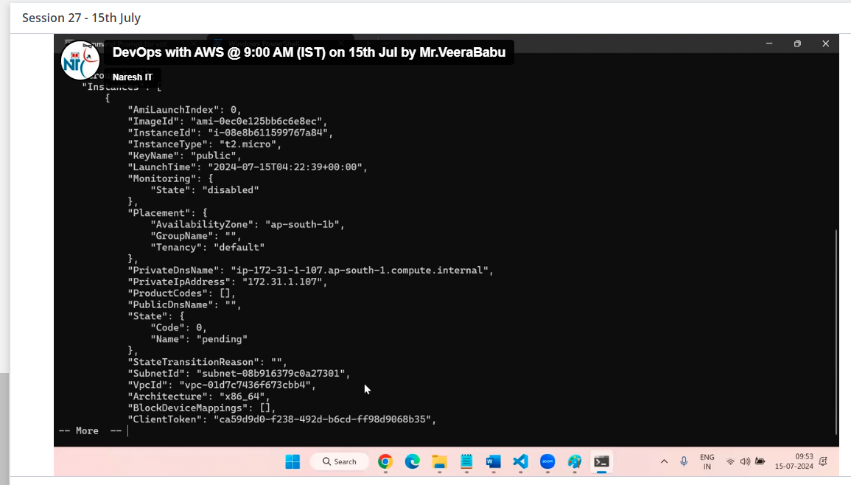

The above all are default polices

If you have to give access only for specific ones for example access for only one instance instead of 4 instance

Here we have to go with custom policies that is fine grain access

So need to create own polices

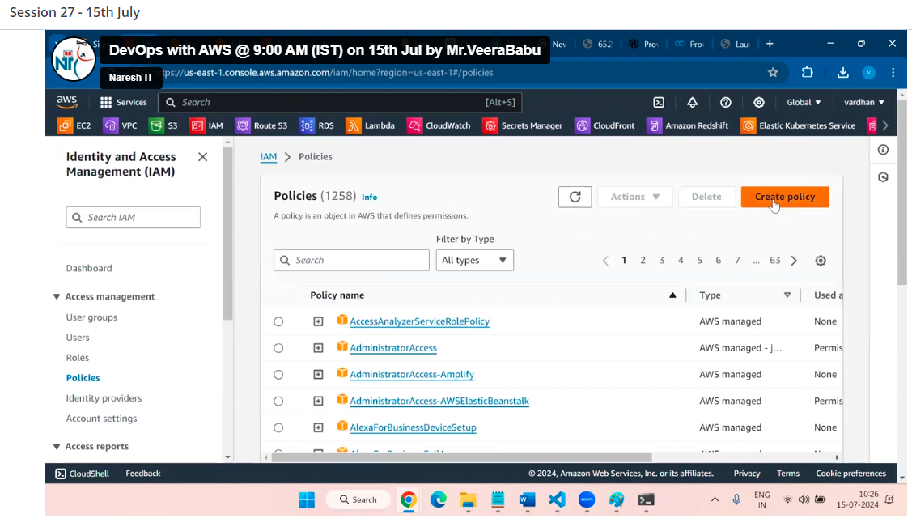

Here for example selected ec2 permission

Select required actions below

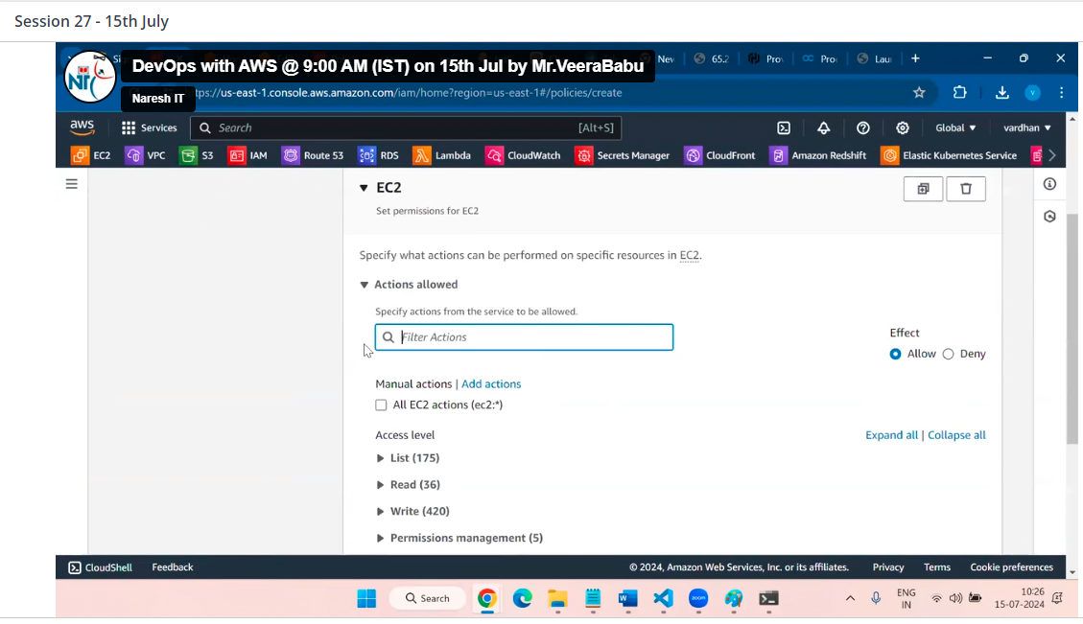

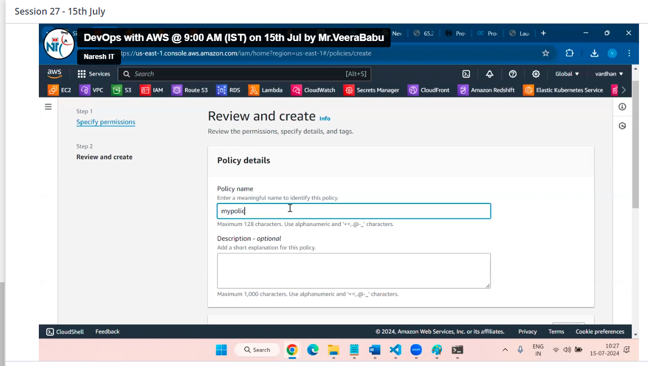

Press on create policy

Then

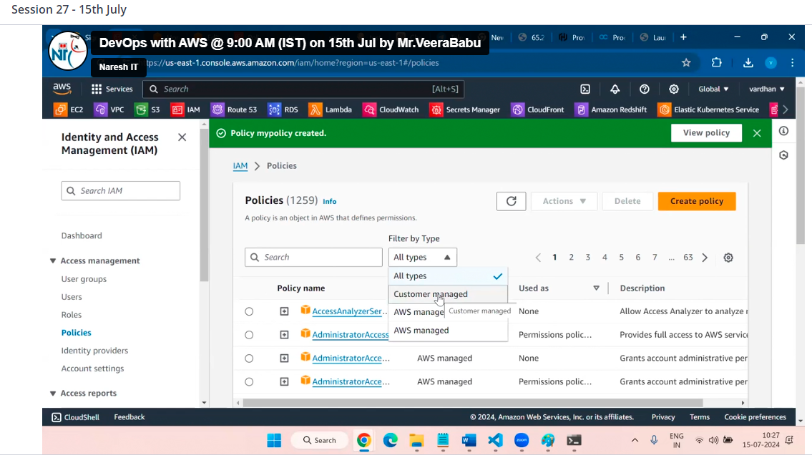

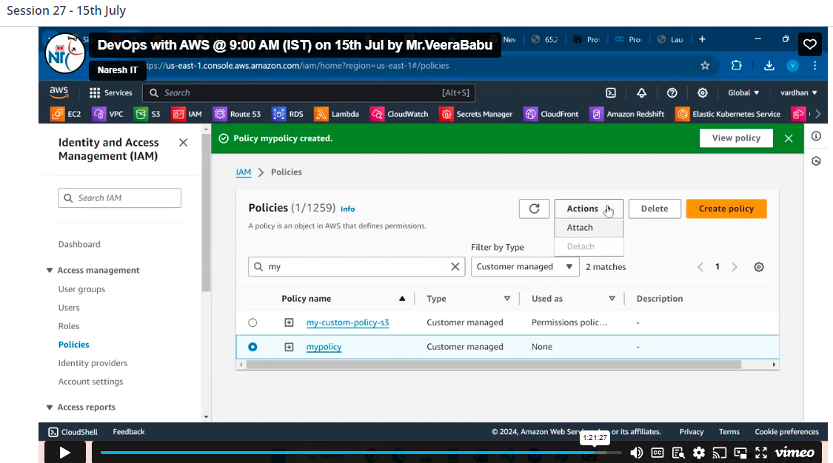

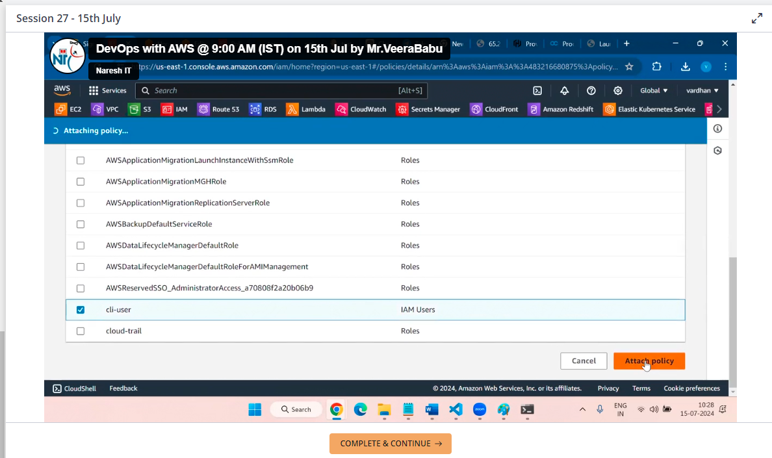

Or

Click on user

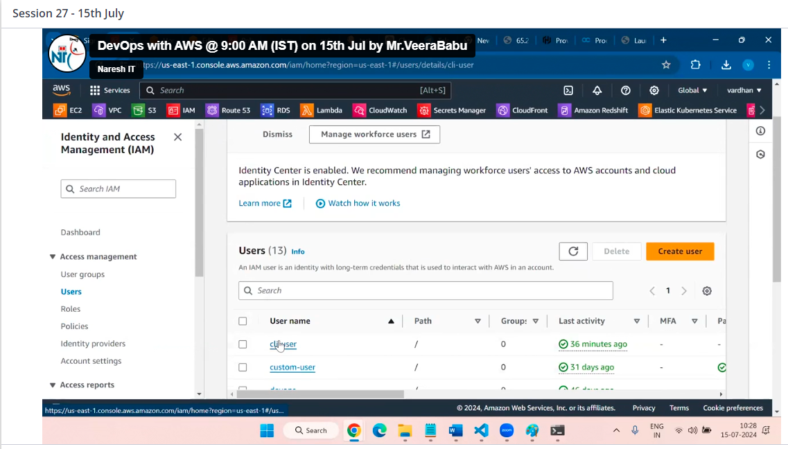

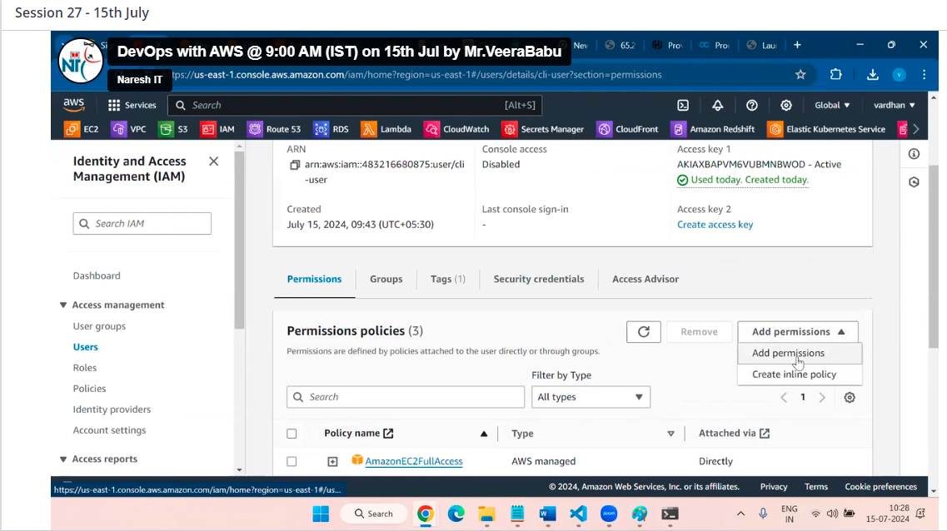

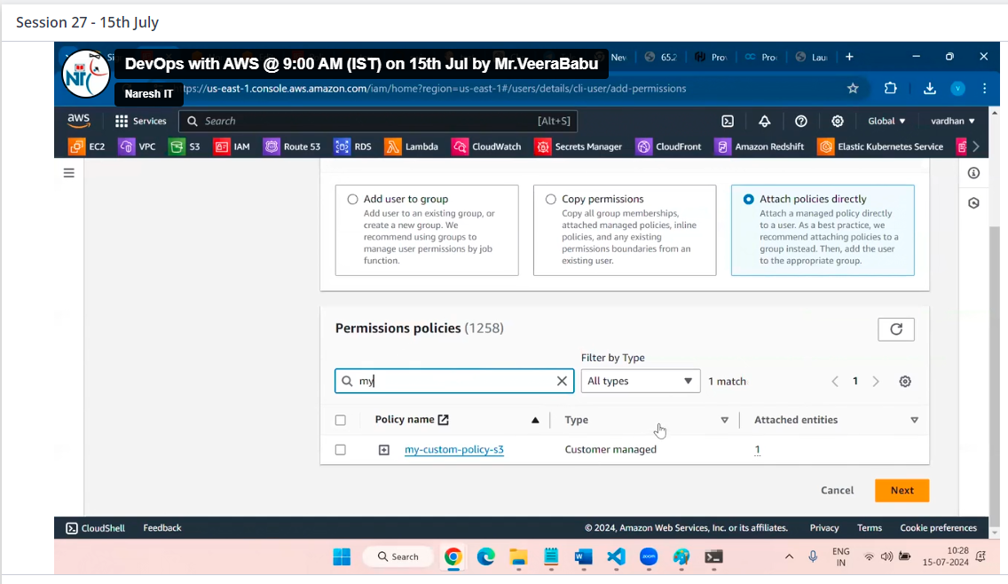

You also attach by this